**20IT6205A: AGILE SOFTWARE DEVELOPMENT**

**Home Assignment**

**A.Y: 2022-23**

**Name:**  MOHAMMAD RIZWANULLAH **Roll No:** 208W1A1299

1. **Name of the project:**

Web App to manage the customers of a CA Firm.

1. **Describe the application/ software/ prototype/ product:**

The Web Application is to manage the customers of the CA Firm. Each customer is identified with the help of his login credentials. The users of the web application will be able to see their filed returns like(GST,IT etc) and are able to send their documents through the website to get signed with the CA Firm and will be able to download the signed documents through the application.

1. **Objectives of application/ software/ prototype TV/ product with respect to HOT analysis framework:**

**HUMAN PERSPECTIVE:**

* This project aims at reducing accidents caused due to driver’s drowsiness with the help of computer vision.
* This not only saves the life of the driver but it also saves the life of other people on the road.

**ORGANIZATIONAL PERSPECTIVE:**

* This provides many profits for the organization as it can be instilled in many automobiles clearly making it very useable and profitable.

**TECHNOLOGICAL PERSPECTIVE:**

* To Train model in such a way that it detects face of a person and also co-ordinates of eyes.
* Implement a novel deep learning approach to execute eye detection frame to frame.

1. **Team Forming: Give the details of your team in the below table format:**

|  |  |  |  |
| --- | --- | --- | --- |
| **Student’s Name** | **Student’s ID** | **Department** | **Electronic-Mail** |
| MD RIZWANULLAH | 208W1A1299 | IT | 208w1a1299@vrsec.ac.in |
| D MAHITH PAUL | 208W1A1282 | IT | 208w1a1282@vrsec.ac.in |

1. **Describe the role schema with respect to your project and elaborate on your role:**

|  |  |  |
| --- | --- | --- |
| **Student’s Name** | **Student’s ID** | **Role Schema** |
| MD RIZWANULLAH | 208W1A1299 | Backend |
| D MAHITH PAUL | 208W1A1282 | Frontend |

**Details of my role:**

My role in the project is the complete backend functionality which includes Authentication, Authorization and creating an Admin panel to make the work of admin simpler to manage the customer’s files and permission. The testing of the functionalities and Deployment of the Application and controlling the environment. Handling errors and bugs encounter in real time.

1. **Your team is told that if the project it is working on is successfully completed on time, the team will receive a bonus. Five options for bonus allocation are out lined below. Please explain how each option might influence team cooperation, and select the option you prefer:**

|  |  |  |  |
| --- | --- | --- | --- |
| **CASE** | **Personal Bonus (% of the total bonus)** | **Team Bonus (% of the total bonus)** | **How this option may influence team mates cooperation** |
| A | 100 | 0 | It effects the team cooperation as if only a person is getting all the bonus even after the whole team works hard for the project. |
| B | 80 | 20 | This case is almost similar to that of the case ‘A’ but a little bit less as team is getting 20% bonus, but this kind of distribution leads to lack of cooperation in team. |
| C | 50 | 50 | This type of distribution do not lead to any kind of issues and help to maintain the team cooperation. |
| D | 20 | 80 | Since the team bonus is much greater than the personal bonus there will not be any kind of issues and thus team co-operation can be maintained. |
| E | 0 | 100 | Since all the members are receiving the same bonus and complete bonus, team co-operation can be maintained without any issues. |

I prefer the last option as whole team is paid equal amount of bonus which leads to harmony in the team and do not lead to any kind of problems or issues within the team.

1. 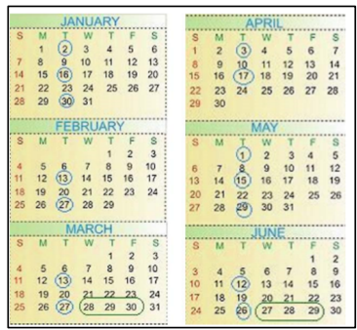**Give out the schedule of your project by calculating the iterations and business days:**

|  |  |  |  |
| --- | --- | --- | --- |
| **S.NO** | **DAYS** | **DESCRIPTION** | **SCHEDULE** |
| 1. | Business Day | This period is working period.Generally,6 days in a week. | Monday - Saturday |
| 2. | Development Day | In 6 days,5 days is spent for developing app functionalities and testing them with various values. | Monday-Friday |
| 3. | Deployment Day | Last business day is for deploying the web Application and testing again after deployment to check if there are any errors. | Friday |

1. **List few functional requirements:**

* Mobile Responsive
* Integrating Amazon AWS S3
* Integrating SendGrid mailing service
* Using MongoDB Atlas
* Authentication ( passport module)
* File uploading & downloading

1. **What metaphors would you suggest for your project? Explain why?**

* Life is a highway

This metaphor is considered because life Is not a short path it’s a long path and we need to learn and will learn so many new things while going through this and the meaning related to the project is there are many new and different technologies which can be used and which makes the development simple.

1. Elaborate on the Time-Related Problems that you faced in your Project:

* Time available to us is less but the project need more time to be developed efficiently.

1. Draw a graph describing the estimation development and actual development with development days in x –axis and no of hours your team worked on project on y- axis. There will definitely be a delay in the actual development, Explain why?

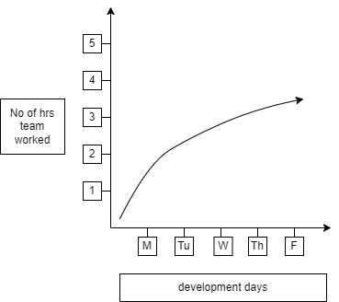

1. **Define Quality with respect to your project and how do you measure it?**

* The quality in this web app can be considered how efficiently a user can use the services provided by the firm with easy to understand user dashboard.
* If all the users are able to understand the features of web app correctly then this is considered as a quality product.
* This can be measured with bounce rate of web application and user surveys.

1. **Is your team diverse? If so, in what sense? Do you benefit from this diversity? If not, why? If so, how? If your team is not diverse, what is common to all the team members? Describe something specific.**

* Yes our team is diverse.
* Both of us the team members have the strong foundation in **frontend** development.

And I have the clear knowledge about **backend** development also.

1. **Describe a scenario that illustrates how diversity may harm agile teamwork. What characterizes such scenarios?**

* As the team is diverse with both frontend and backend skills but the backend developer has the knowledge of frontend also he can mange either of the work.
* In the reality the backend work is whole lot more than the frontend work so the backend developer has to do more work than other member but with the same and equal bonus.

1. **Describe the learning that we have achieved from your overall project work?**

* The are many learnings from the project the main learning is the good coding practice to make an efficient backend business logic.
* There has been a chance to explore all the different hosting providers and tested by deploying the application using their services.
* Real time learning of how backend talks with front end how the templating engine is used in the website.
* The TDD ( Test Driven Development ) is practiced a lot while working in this project which was a very good learning and experience.